# Lab Week 1.B. Loops

### Last Part

* Program flow
* Using Variables
* Drew a face, then a stick person of size and position dictated by variable values.

## Learning Objectives

* Using For Loop
* Local variable – for loop counter
* Using Nested loops

## Resources

* Lecture Notes
* Processing website – reference
* https://processing.org/reference/for.html

**Exercise 1** [tutor talk through]

int x=10;

int y=20;

size(100,100); //set size of canvas screen

for(int i=0;i<5;i=i+1)

{

x=x+10;

print(" i:"+i+",x:"+x); //display variable value in console window

ellipse(x,y,5,5);

}

Enter the code precisely as above, and run.

Note the print command, prints the value of local variable **i** and global variable **x** to the console (bottom of sketch window)

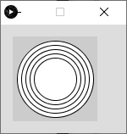Alter the code so we get a horizontal line of 10 circles on the screen. You may have to increase the size of your canvas.

Write a new program so that you get 5 concentric circles in the middle of the canvas

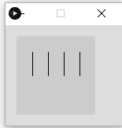

Code to produce 4 parallel lines of length 50, 20 pixels apart.

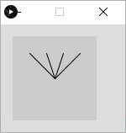

Code to produce, this pattern. Note this is similar to the previous problem, but the end points of all the lines are the same.

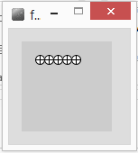Ex1.1 Alter the code so that it draws 5 wheels (a cross within a circle).

Ex1.2 Produce some code to draw wheels across the screen using a while loop

[hint : **width** is a built-in variable that holds the width of the screen]

Ex1.3 Produce code to draw 10 wheels in a vertical line

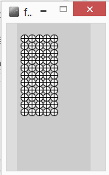Ex1.4 Alter the code so we get a block of wheels – 5 wide, by 10 deep

**Exercise2**. Produce a program to draw the images

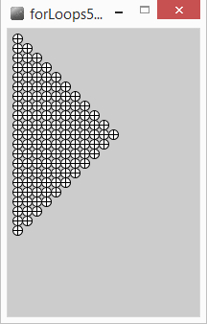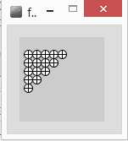

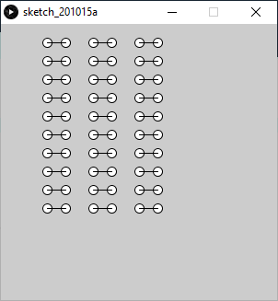**Portfolio 1.** Produce a program to draw the pattern

Design stages,

Draw a dumbbell, 2 ellipses and a line from each centre

Draw a column,

Draw 3 columns

Good solution should show evidence of the design (comments), use all concepts covered so far. Best solutions will allow easy rescaling and repositioning of the pattern.

**Exercise 3** Try out the code below, what does it do and why?

float x= 25;

float y=25;

float radius = 20;

float angle; //in radians

for(int degrees=0; degrees<360; degrees = degrees+10)

{

angle = **radians**(degrees); //convert degrees to radians

**line**(x,y, x+radius\***sin**(angle),y+radius\***cos**(angle));

}

Put the code below into the for loop to change the colour of each ‘spoke’.

float r = **random**(50); //random number [0..50]

float g = **random**(50);

float b = **random**(50);

**stroke**(r*5,g*5,b*5); //random line colour

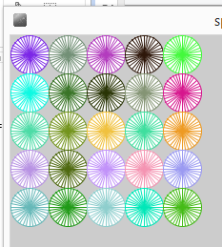

**Exercise 4**. pop art wheels, a 10 by 10 block of wheels, each of a different random colour

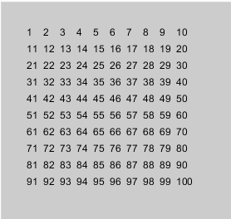**Homework exercise**.

text("*", 100,100); //draws a text string ‘*’ at position 100,100

int count=10;

text(“”+count, x,y); //draws value of count at x,y

draw the image, left.

Extension exercise (optical illusion), needs an if statement and a Boolean variable ( a flag )

